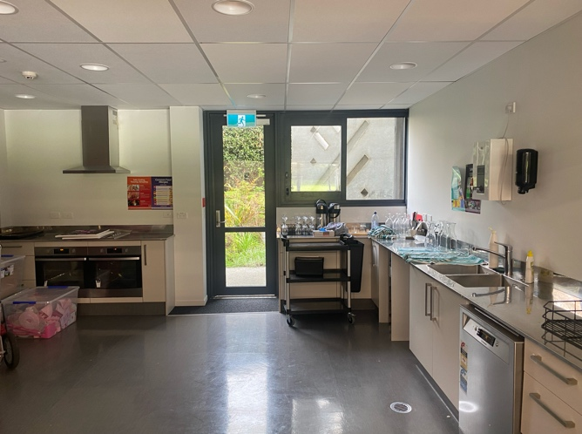 | Kitchen:  - One of the most prominent locations in our short film is the restaurant  kitchen setting at the beginning. We have chosen to use our schools kitchen inside the Dance studio as it is convenient in the sense of its location and it also has a commercial vibe.  Health and Safety in the Kitchen:  - The kitchen has various elements that can bee seen as a health and safety hazard. Individual photos and analysis is below.
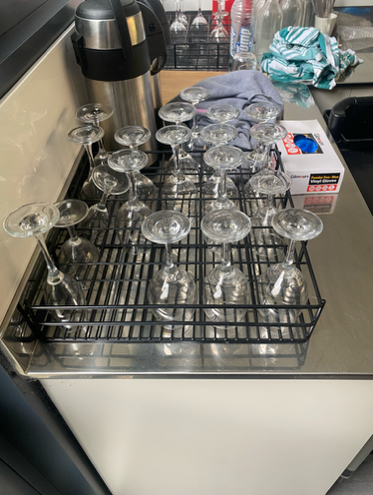 | Various Glass cups and bottles:  - In the case of somebody knocking them over and shattering them, the sharp glass proposes a hazard that should be avoided.  Ways to avoid:  - Make everyone in the kitchen aware of the risk and stress the importance of knowing your surroundings.  - As not essential to the kitchen look - putting them away in cupboards could be an option as well.
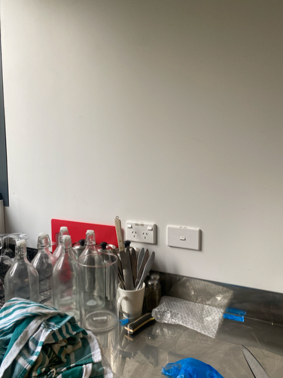 | Cutlery and more glass kitchenware:  - For glass kitchenware see above  - Knives and forks especially propose a risk due to their sharp edges which can cause damage to the human body if contacted in the wrong way.  Ways to avoid:  Especially due to the fact knives will be used to cut in our scene, knowing how to use the equipment safely is a must.  - Making sure to educate all using a knife on how to do so properly  - Again making sure people are aware of their surroundings so as not to knock anything over that may propose a cutlery risk to any member in the kitchen.
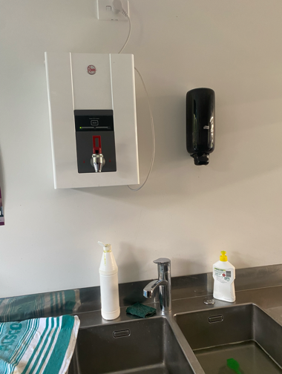 | Boiling water taps:  - Harmful to the skin when came into contact.  Ways to avoid:  - Make everyone aware of the risk that comes along with the boiling water taps, and stress the importance of not toying with them.
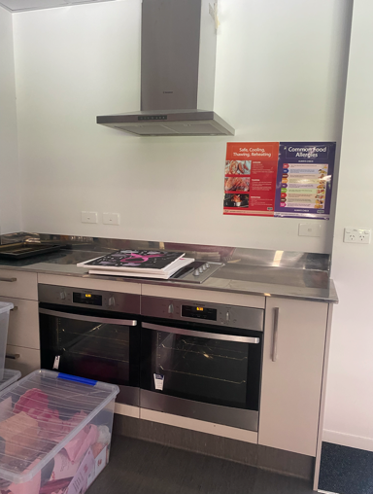 | Stove tops and ovens:  - The stove top in particular will be in use during the kitchen scene and it proposes itself as a risk due to its hot elements which can cause serious burn to human skin when touched for more than a few milliseconds.  How to avoid the risk:  - Make sure anyone involved in using the stove knows exactly how to use it.  - Ensure everyone knows not to touch the stove and the risks that come along with it.
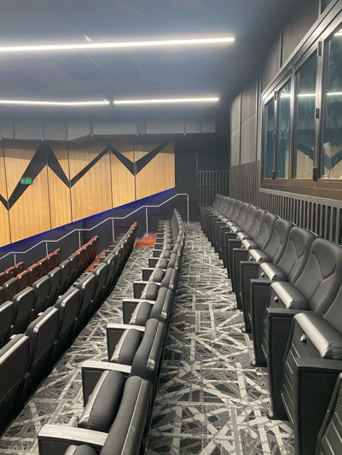 | Theatre:  This was a supposed filming location however we have now decided against its use. In case of possible future use, its main risks involving tripping hazards regarding the chairs and stairs.  The photo below is what was going to be used for the news reporting station. Its main risks were tripping hazards and electrical hazards regarding the various cables inside.
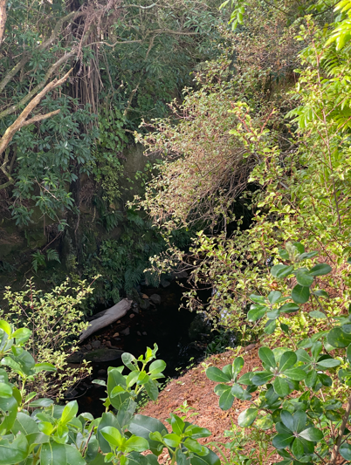 | Creek:  - This is located behind our chosen sport for filming the news reporter scene. Its main risks involve the river band and the creek itself.  - Ensure everyone stays at least 5 meters away from the sloped part of the bank as to prevent any possible slips and falls.
What to do in the case of a problem:
  - Evacuate everyone out of the kitchen in the case of breaking anything that proposes a shard hazard. Follow this up by either vacuuming or using a dustpan and brush to clear the floor.
  - In the case of any burns - run the affected area underneath cold water for 3-5 minutes and if somewhat severe use an icepack or seek further help from the nurse.
  - In the case of any cutlery problems, sterilize and wipe the affected area of skin and cover with a bandage.
  - Slip and fall from the bank: Allow one person to go notify an adult and leave another to stay with the person who has fallen. Do not try and go down the bank to rescue as to avoid any further issue. Depending on the severity of the injuries, make actions accordingly

