file:///Users/madisynatkinson/Downloads/Jocelyn%20(1).mp4
file:///Users/madisynatkinson/Downloads/Jocelyn.mp4
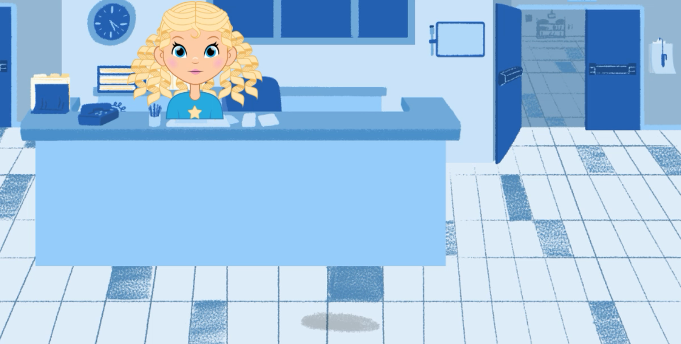
file:///Users/madisynatkinson/Downloads/Jocelyn%20(2).mp4

